
CTS Tiguan Downpipe Install Instructions
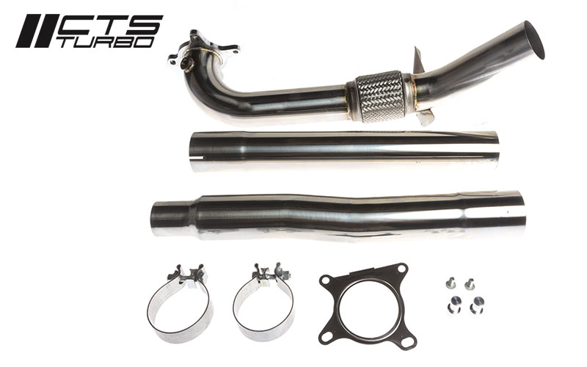
Included in the kit: 3 Piece Downpipe, 2x Accuseal Clamps, Gasket, Hanger Mounts, 2x M6 bolts
Have the following tools at hand:
- Ratchet
- 22mm wrench
- 16mm socket
- 13mm socket
- 10mm socket
- 10mm 12 point
- T25 Torx
- Exhaust hanger removal tool
Pro Tip: Soak the downpipe nuts in a penetrating fluid (ie: pb blaster) prior to starting the install. Make sure the car is cooled off before starting the install.

Step 1: Lift the vehicle on jackstands or hoist. Using your 13mm socket, undo the 2x 13mm bolts holding the belly pan to the subframe. Use your T25 Torx to remove the 7 torx screws as well. Pull the belly pan free of the car.
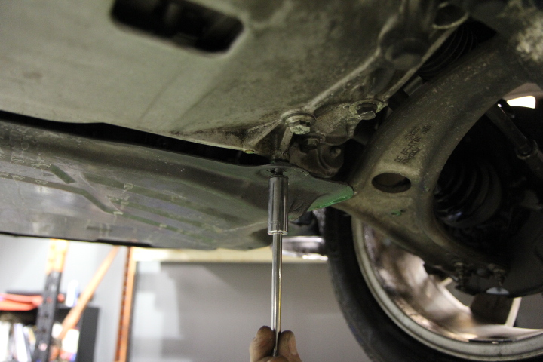
Step 2: Use your 10mm socket to remove 2x 10mm bolts holding the driveshaft heat shield in place. Pull the heat shield free of the car. This will not be reattached.
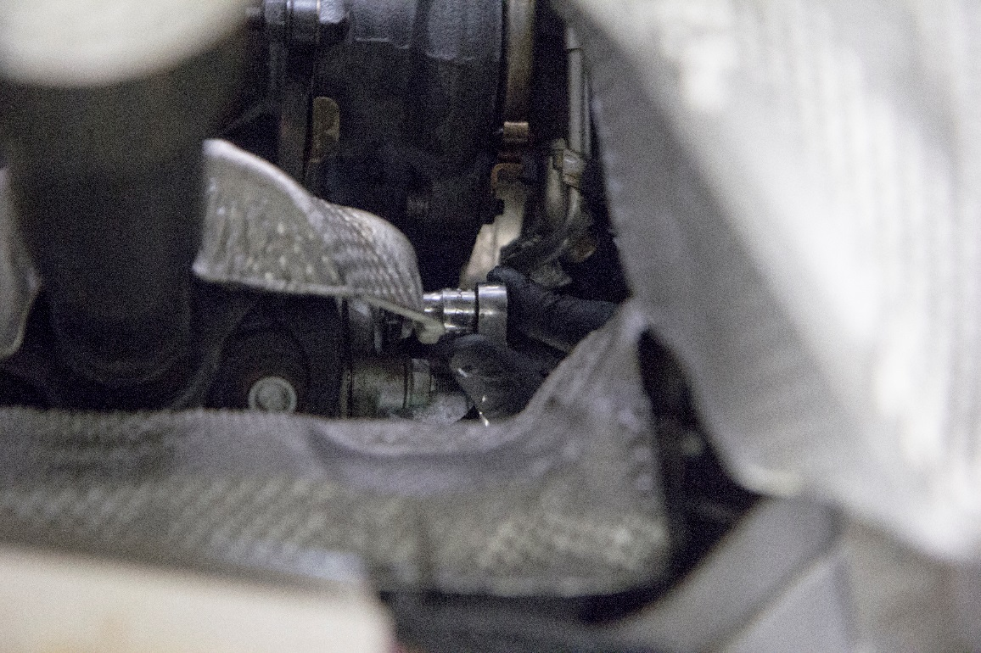
Step 3: Use your 21mm socket to undo the dogbone mount bolt and set aside.
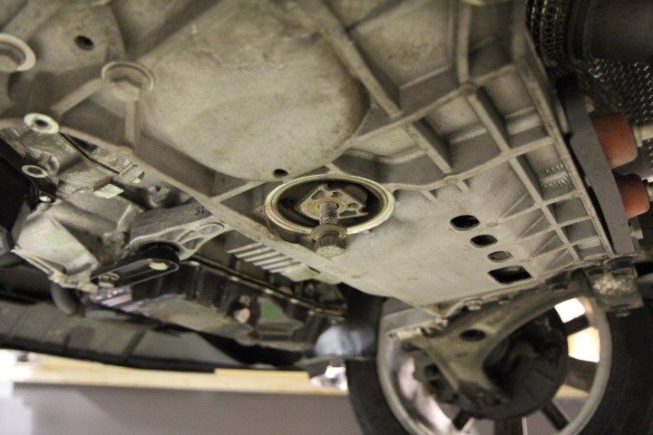
Step 4: Using the 10mm 12 point, remove the 3 bolts attaching the driveshaft to the transmission. Spin the 2 front wheels together to rotate the driveshaft allowing access to each bolt. Pull the driveshaft towards the rear of the vehicle and off of the flange. Push to the right side.
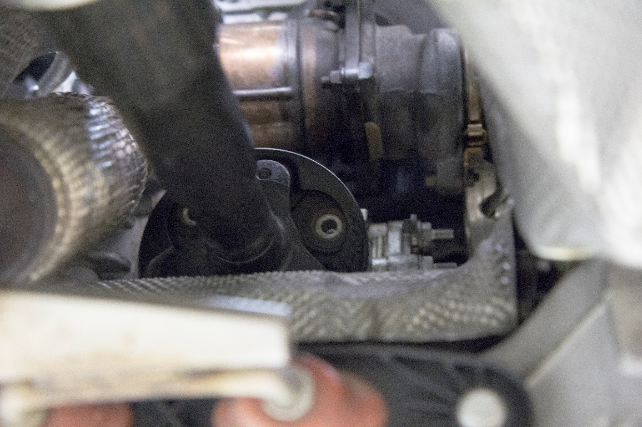

Step 5: Use your 22mm wrench to remove the secondary 02 sensor from the OEM downpipe.
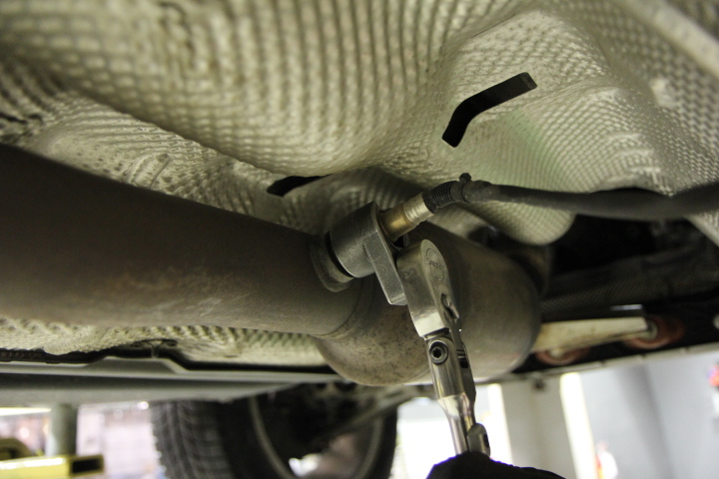
Step 6: Move to the top of the engine bay and remove the stock airbox and intake. Use your 22mm wrench to undo the upper 02 sensor.
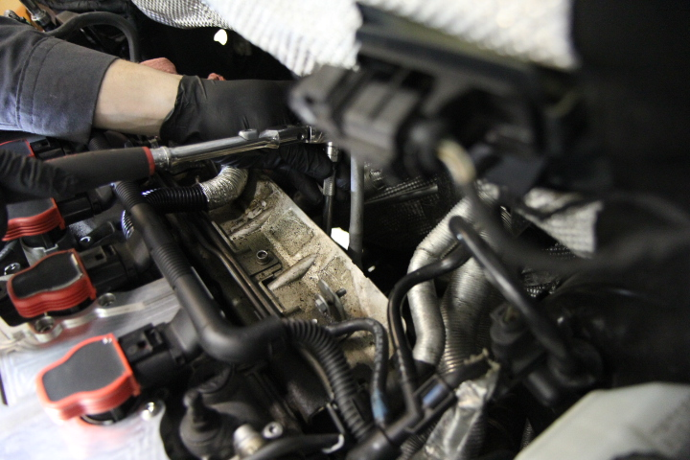

Step 7: Using your 16mm socket and extension, align your tool as shown to remove the upper forwardmost downpipe nut. Remove the 2nd upper nut as well. Move to the bottom of the car to remove the lower 2 retaining nuts.
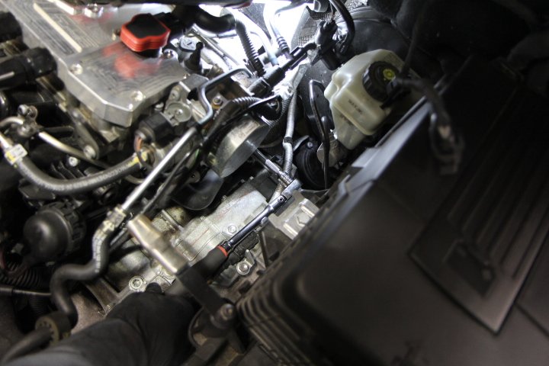
Step 8: Using your 13mm socket, remove the downpipe hanger bracket from the subframe.
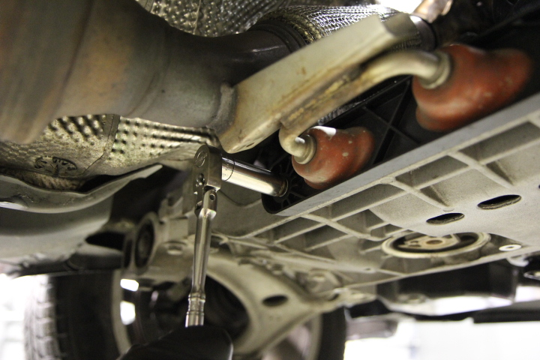
Step 9: Using your 13mm socket, undo the 2 bolts holding the OEM exhaust clamp to the catback. Slide the clamp towards the rear of the vehicle. Manuver the downpipe down and out of the vehicle.
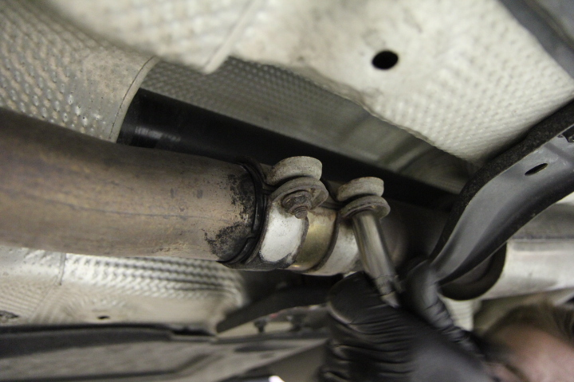
Step 10: Use your exhaust hanger removal tool and transfer the hanger from the OEM downpipe to the CTS downpipe.
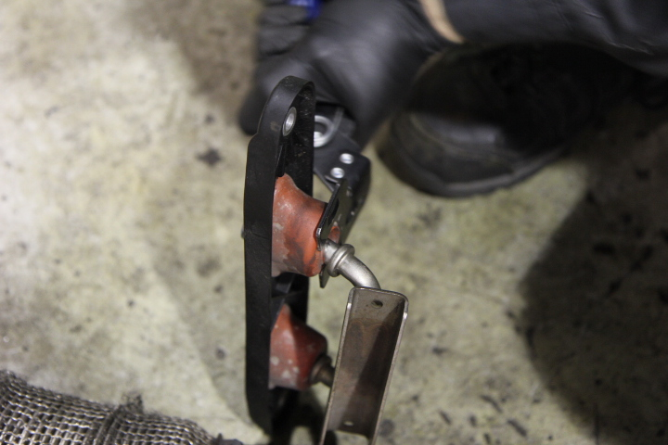

Step 11: Place the gasket over the turbine housing studs. Gasket is included in install kit (optional).
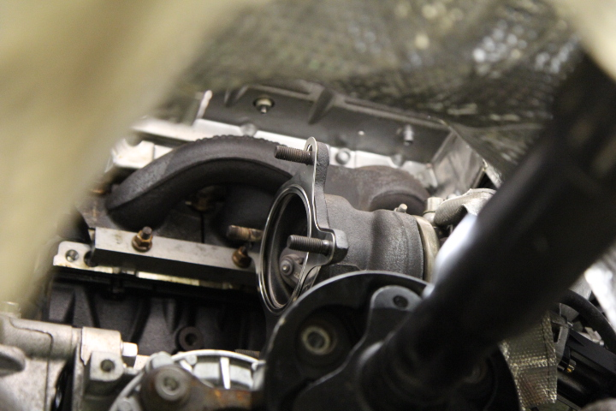
Step 12: Install the CTS downpipe and use new copper locknuts. Locknuts included in install kit (optional).
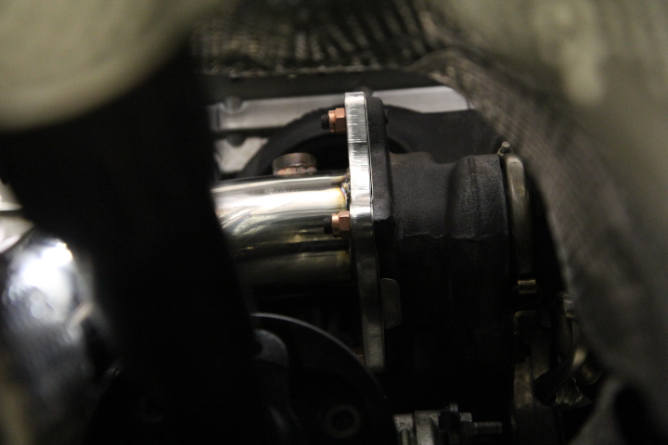

Step 13: Slide the 2 remaining downpipe sections into place and secure the 2 joints with the supplied accuseal clamps.
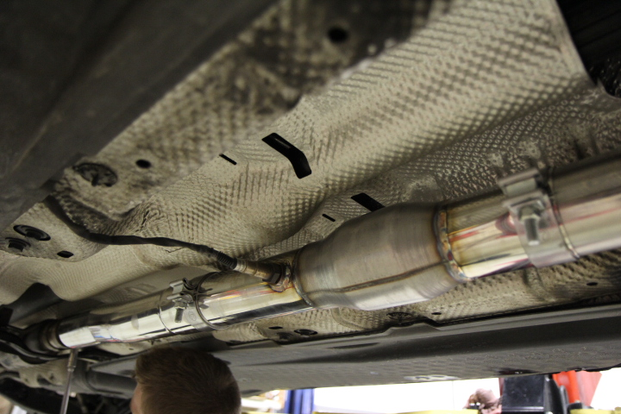
Step 14: Reverse steps 9, 8, 6, 5, 4, 3 and 1 to complete the installation.
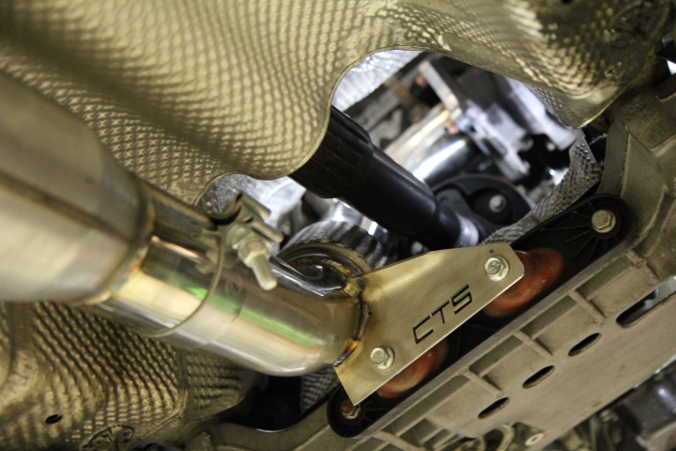

You are done!



